 v

**Version 3.0**

**April 29, 2013**

**Carrier Enrollment Interface Control Document**

1. Table of Contents

1 Introduction 1

2 Service Overview 1

2.1 Purpose 2

2.2 Functionality 2

2.3 Participants 3

2.4 Service Obligations (General) 3

2.5 Out of Scope 3

3 Assumptions and Issues 4

3.1 Assumptions 4

3.2 Issues 4

4 General Interface Requirements 5

4.1 Functional Summary 5

4.2 Business Process 7

4.2.1 Create Employer Group 7

4.2.2 Group Maintenance – Initiated by VT HBE 8

4.2.3 Group Maintenance Initiated by Carrier 9

4.2.4 Employee Enrollment 10

4.2.5 Employee Maintenance Initiated by VT HBE 11

4.2.6 Employee Maintenance Initiated by Carrier 12

4.2.7 Individual Enrollment 13

4.2.8 Individual Enrollment Maintenance Initiated by VT HBE 14

4.2.9 Individual Enrollment Maintenance Initiated by Carrier 15

4.3 Service Operations 16

4.4 Data Handling 17

4.4.1 Group Operations 17

4.4.2 Enrollment Operations 17

4.5 Process Controls 18

4.6 Security and Integrity 18

5 Detailed Interface Design 19

5.1 Event-Driven Sequences 20

5.1.1 New Group 21

5.1.2 New Enrollment 24

5.1.3 Enrollment Change 25

5.2 Message Data 26

5.2.1 GA1 (Request Message) 26

5.2.2 GA2 (Response Message) 30

5.3 Packaging and Delivery 30

5.3.1 Technical Plan – SFTP Exchange 31

5.3.2 System Architecture 32

5.4 Transactional Requirements 32

5.5 Security Management 33

5.6 Business Rules 33

5.7 Exception Handling 33

5.8 Service Performance 33

6 VT HBE Process Implications 33

7 General Qualification Plan 34

Appendix A: Acronyms 35

1. Table of Figures

Exhibit 1: Functional Summary Diagram 6

Exhibit 2: Group Create Process 7

Exhibit 3: Group Maintenance Initiated by VT HBE 8

Exhibit 4: Group Maintenance Initiated by Carrier 9

Exhibit 5: Employee Enrollment 10

Exhibit 6: Employee Maintenance Initiated by VT HBE 11

Exhibit 7: Employee Maintenance Initiated by Carrier 12

Exhibit 8: Individual Enrollment 13

Exhibit 9: Individual Enrollment Maintenance Initiated by VT HBE 14

Exhibit 10: Individual Enrollment Maintenance Initiated by Carrier 15

Exhibit 11: Web Services Hosted by VT HBE 16

Exhibit 12: Web Services Hosted by Carrier 17

Exhibit 13: Basic System Components 20

Exhibit 14: New Group Sequence 21

Exhibit 15: Group Change Sequence 22

Exhibit 16: New Enrollment Sequence 24

Exhibit 17: Enrollment Change Sequence 25

Exhibit 18: GA1 Header Data 26

Exhibit 19: GA1 Body Data 26

Exhibit 20: GA2 Header Data 30

Exhibit 21: GA2 Body Data 30

Exhibit 22: SFTP Exchange Technical Plan 31

Exhibit 23: List of Acronyms 35

**Revision History**

|  |  |  |  |
| --- | --- | --- | --- |
| Version | Date | Modified By | Description |
| 1.0 | 03/08/13 | David Jurk | Initial draft |
| 2.0 | 04/05/13 | David Jurk | Revisions based on Carrier feedback |
| 3.0 | 04/29/13 | David Jurk | Revisions based on Carrier discussions |
|  |  |  |  |
|  |  |  |  |

# Introduction

This document describes the message exchanges that are required between the State of Vermont healthcare insurance carriers and the Vermont Health Benefit Exchange (VT HBE), as part of the process of enrolling citizens of Vermont – both individuals and employees - into Qualified Healthcare Plans (QHP).

The scope of this ICD is intended to encompass the fundamental aspects of messaging required for the enrollment process, including establishing employer plan groups, handling initial enrollments for both individuals and employees, and providing for the general maintenance functions, such as changes to household coverage and disenrollment, as well as reconciliation. In addition, federal agency (CMS) requirements related to reporting and reconciliation of enrollments are also included.

Details of document interfaces, transaction processes and operational protocol are addressed within. Supporting documents that may add additional insights into specific aspects of the process are referenced.

# Service Overview

The Individual and Employee Enrollment Interface Control Document (ICD) describes the following three fundamental services, with the goal of providing a comprehensive functional provision of all enrollment-related activities:

* The creation and maintenance of employer plan groups within which employees may enroll
* The enrollment of both unaffiliated individuals into a qualifying healthcare plan or enrollment of an employee into a qualifying group plan
* Maintenance related to those enrollments, in the form of additions, changes, or dis-enrollments of various kinds

These activities support the process of enrolling individuals into a qualified healthcare plan through the VT HBE, regardless of whether the channel followed by an applicant is via the online Portal, or through walk-in/call-in centers.

All of these service activities are described, within the ICD, in terms of infrastructure, operational processes, and the detailed exchange of ANSI 834 X12N Benefit Enrollment and Maintenance files (and other mechanisms where appropriate). They describe a variant of EDI standards in terms of acknowledgement/response messages, as well as operational support practices for dealing with security, exceptions, and problem resolution.

This document depicts a service whose message exchanges establish a communication mechanism between two parties (VT HBE and Carriers) in the following structure:

* **From the VT HBE to the Carriers**
* To establish and maintain employer groups of qualified healthcare plans
* To enroll and maintain enrollment status of employees and/or their households into an employer-based QHP
* To enroll and maintain enrollment status of unaffiliated individuals and/or their households into a QHP
* **From the Carriers to the VT HBE Integration Hub**
* To transmit effectuated enrollments
* To maintain employer group status

## Purpose

As intended by the Affordable Care Act (ACA), the VT HBE will be a facilitator, and system of record, in the provision of healthcare coverage to its eligible citizens seeking it. It is intended to bring issuers and applicants together and streamline and operationally ease the task of applying for and enrolling in a healthcare plan.

The enrollment services described in this document are central to achieving that goal – it provides for the fundamental act of bringing citizen and Carrier into a direct, formal relationship.

This ICD, in describing those enrollment services, provides messaging for the core aspects (other than financial elements, which are described in a separate ICD) of the management of that contractual relationship, with the Exchange serving as the further facilitator by which all parties can initiate and coordinate maintenance events to that contractual status.

Finally, it provides necessary tracking to the federal government, for tax credit calculation purposes.

## Functionality

* **Establish and maintain employer group plans**

When eligible employers use the Exchange, they create employer groups based on one of several profiles, such as a medal-plan based, single carrier, single plan, etc. At the point that open enrollment closes for those employer-created plans, the plans must be identified to the carriers involved (there may be multiple carrier’s plans contained in a given employer group plan) and created within the carrier to be made available for subsequent employee enrollment.

There are circumstances under which either the VT HBE or the Carrier might initiate changes to, or cancellation of a particular Group. For instance, from the Carrier perspective, they may need to initiate the termination of a Group and from the VT HBE perspective, they may need to notify Carriers of Group address or contact information changes.

* **Enroll Employees in those group plans**

Once employer groups are identified to a carrier or carriers, the employees of that employer (termed the ‘roster’) need to be identified in a standard way and subsequently enrolled by that carrier into the group plan.

* **Enroll Individuals in a healthcare plan**

Non-affiliated citizens (those not under the umbrella of an employer-provided plan) need to have the same ability to use the exchange to enroll in a qualified healthcare plan. Other than the identification of an employer group membership for employee enrollments, functionality for employees and individuals is virtually identical.

* **Provide for enrollment maintenance operations for both Individuals and Employees**

Whether an existing plan enrollee is unaffiliated or is an enrollee of an employer group plan, a facility must be created to handle enrollment maintenance operations. These can come from several sources – Carriers, enrollees, or VT HBE. Examples of these include changes in dependency status, additions to coverage, changes in coverage details, and termination of coverage.

## Participants

* **VT HBE**

VT HBE here refers generically to the VT HBE system, which is actually composed of several architectural layers. Of particular interest to this ICD is the VT HBE Integration Hub (HIH), the infrastructure of which is built using the Oracle SOA Suite and Oracle Service Bus, and comprising a set of services – the interfaces for which are described in the series of ICD artifacts.

In addition, the VT HBE Portal (the public user interface component of the HBE system) plays a crucial role in these processes, as it is typically the layer that initiates these service calls as the business client, working through the middleware and outward to external partners such as the Carriers.

* **Carriers**

The Carriers here refer to QHP issuers of QHP’s for citizens utilizing the VT HBE system (either through the Portal or through Customer Walk-or-Call in Centers). Specifically, in terms of these ICD documents, Carrier refers to some defined infrastructure such as a Carrier-provided Web Service or Secure FTP file repository.

## Service Obligations (General)

* **VT HBE**

VT HBE services, in the case of enrollment operations, are provided entirely by the VT HBE Integration Hub (HIH), which serves as a mediation layer between the UI and business logic of the VT HBE Portal on one side, and external resources such as CMS and the Carriers on the other.

HIH is the sole gateway through which the VT HBE Portal and business logic components communicate to the external world.

* **Carriers**

The Carriers’ service obligations, as both a client and provider of services, is similar to that of HIH, in that each Carrier has a transactional obligation to acknowledge service calls made to it, as well as performing file confirmation activities as described in detail elsewhere in this document.

## Out of Scope

The following items are not included in the scope of this interface:

* Integration and enrollment related to other, non-VT HBE healthcare programs and systems, including ACCESS
* Integrated Eligibility
* CMS interfaces for purposes of transmitting Effectuated enrollment data
* Reconciliation processes

# Assumptions and Issues

This section discusses the assumptions and issues concerning the VT HBE project.

## Assumptions

The following are the assumptions associated with the VT HBE project.

* All web services described in this ICD will follow the same general pattern; the only synchronous response will be an acknowledgement. As described below, significant message content exchanges will be asynchronous.
* Group ‘create’ messages will be sent to all appropriate Carriers even in the absence of any active enrollees. Carriers are free to act on those messages at their discretion.
* All Carriers will use the same WSDL/XSD structures and 834/999 layouts.
* Carriers will provide Web Service and SFTP resources for their own services; no hosting of Carrier services will be provided by the SOV.
* EDI X12N 834/999 artifacts will be consistent with CMS FFE specifications, except where Carriers and VT HBE agree on specific customizations.
* Carriers will log all activity – both web service messaging and file transfers.
* Carriers will implement appropriate security measures (as described in the *Carrier Enrollment ICD Companion Guide*) for all web service and SFTP services they provide.
* Issue resolution, at least at the outset, will be primarily manual. In other words, even though a system process raises a logical business error (for example, an 834 change operation is received by a Carrier for an enrollee they have no record of), the VT HBE will leverage manual resolution over automated systems.

## Issues

The following is a list of issues concerning the VT HBE project. All issues (except the last five issues specifically noted as still Open below) are closed.

|  |  |
| --- | --- |
| Issue | Status |
| Employer addresses – which are mandatory? | Closed |
| Which field values can change outside open enrollment? | Closed |
| What additional header data would Carriers want in SOAP messages (e.g., transaction type)? | Closed |
| We need to provide Carrier ‘profile’ repository in HIH for items like format preferences (e.g., FTP/834 v. SOAP/XML)? | Closed |
| CMS 834 Companion Guide is still a work in progress – some processes and protocols are still TBD | Closed |
| Most error resolution processes still need to be defined | Closed |
| VT HBE/CGI EDI SME’s need to comprehensively review 834 attributes and standards | Closed |
| VT HBE/Carriers need to establish SLA’s for respective services | Open |
| Need keystore key exchange routine | Open |
| Need to resolve newborn procedure with Carriers, VT HBE and Hospitals | Open |
| The list of Group action error codes needs to be determined for the GA2 Group callback message | Open |
| The exact nature of the 834 validation error reporting is pending review and recommendations from carriers; until a common carrier approach is agreed upon, it is excluded from this ICD | Open |

# General Interface Requirements

## Functional Summary

The functionality of the messaging between VT HBE and the Carriers – irrespective of which side initiates the message – can be broken into two fundamental areas: Group Actions and Enrollment Actions.

In each case, either party can initiate a message sequence; that is, the initiation of enrollment operations can come from either VT HBE or the Carrier, and the initiation of group operations can also come from either one.

These functions can be accurately thought of as transactional in nature – an “opening” message is sent, and at some point in the future, a “closing” message is expected back that confirms the successful conclusion of the operation. The nature of that closing message changes, depending on the initial sender and the type of operation. For example, VT HBE will never respond to an enrollment action triggered by the Carrier with Effectuated enrollment data; the Carrier always will.

To be more specific, “opening” and “closing” messages actually comprise the following:

* **Opening** (meaning that they begin a transactional operation)

Initiated by both VT HBE and Carriers, they include the creation and maintenance of employer groups, new enrollments of individuals and employees, and various enrollment maintenance transactions for individuals and employees.

* **Closing** (meaning that they end a transactional operation)

Initiated by both VT HBE and Carriers, they include meaningful response messages such as Effectuated enrollment data by the Carriers, and operational confirmation messages by both Carriers and VT HBE.

In each case, regardless of the specific operation, the party making the call will expect a synchronous response from the receiver, indicating successful receipt of the message. That acknowledgement implies nothing more than a successful transmission – it does not provide closing content.

Opening operations will always be paired with a corresponding Closing operation. These are depicted in the following diagram as “Operational Groups”. For instance, in the case of an enrollment transaction, following the synchronous acknowledgement verify receipt, the Carriers will be expected to initiate a Response operation consisting of specific enrollment data (Effectuation) assigned by the Carrier.

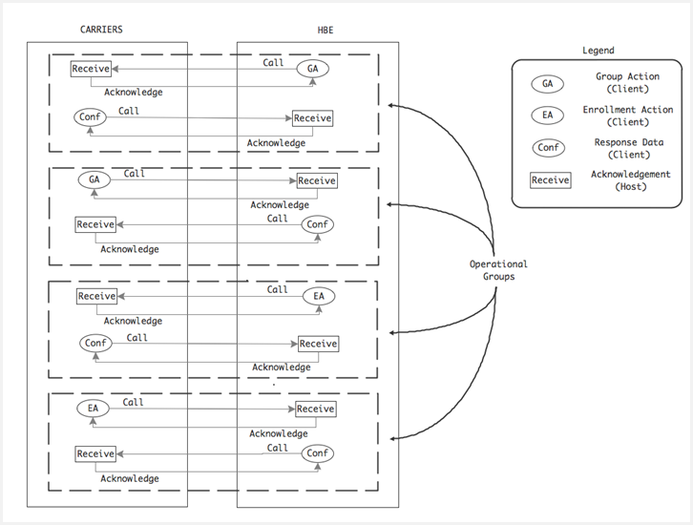

Exhibit 1: Functional Summary Diagram

## Business Process

One way to view the transactional operations listed previously is as a set of services that can be used for a variety of purposes. Within the Exchange, in concert with the Carriers, these services need to be viewed from within the context of the business functions that need them.

There are nine distinct business processes that will utilize the Group and Enrollment actions described in this ICD:

* The creation of employer Groups
* Maintenance of the employer Group, initiated by VT HBE
* Maintenance of the employer Group, initiated by Carrier (Group termination only)
* The enrollment of Employees into their respective employer Groups
* Maintenance of the enrolled Employee, initiated by VT HBE
* Maintenance of the enrolled Employee, initiated by Carrier (Enrollee termination only)
* The enrollment of unaffiliated Individuals into a QHP
* Maintenance of the enrolled Individual, initiated by VT HBE
* Maintenance of the enrolled Individual, initiated by Carrier

### Create Employer Group

The process of defining the plan within the user interface is a potentially complex sequence that involves a series of options that the Employer works through within the VT HBE Portal. This results in a plan profile that determines the nature of the selections an employee can make when enrolling. Note that this profile can create a Group that involves one or more carriers. In the case of a Group definition that involves more than one carrier, it’s certainly possible that no enrollments occur for a given carrier, based on the selections that the employees make.

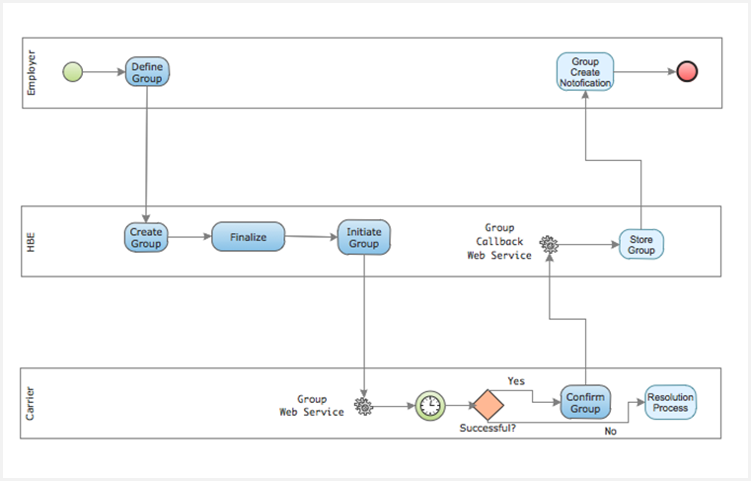

Exhibit 2: Group Create Process

The Group Create process is initiated when the Employer registers with the VT HBE Portal, creates an employee roster, reviews, defines, and selects a group profile. At the point that he or she confirms this within the Portal, the Group is considered ‘pending’ – awaiting confirmation by Carriers.

This results in the creation (within the Portal) of a Group plan or set of plans that an employee can select for themselves and/or their dependents. At this point, the following steps occur:

1. The Group is defined and formally selected, so VT HBE calls the Carriers’ Group Web Service with an operation type of “Create”.
2. The Carrier receives the request, and carries out its own internal processing.
3. If the Carrier is able to successfully establish the Group (or evaluates and believes it can establish the Group in the future), it calls the VT HBE Group Callback Web Service and confirms the creation of the Group.
4. If it finds that some logical issue exists preventing Group creation, the problem resolution for Groups is followed, as outlined in the *Carrier Enrollment ICD Companion Guide*.
5. Group creation status is then transmitted by VT HBE back to the Employer, effectively completing the operation.

### Group Maintenance – Initiated by VT HBE

This process provides for the communication to the Carrier of any significant change to the SOV of an established Group, including elimination of that Group.

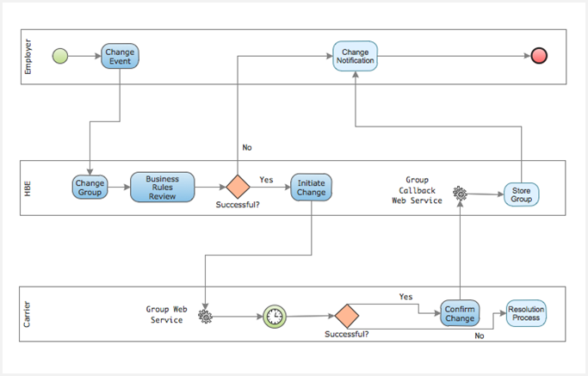

Exhibit 3: Group Maintenance Initiated by VT HBE

This process provides for the communication of a valid change in status of an employer Group, driven either by the Employer themselves or a condition or event that causes the VT HBE system to trigger the change process. The steps, in general, are:

1. The triggering cause, and the nature of the change request, is evaluated against business rules contained within the VT HBE system. If the change request violates business rules, it is rejected.
2. Assuming the change is valid, VT HBE calls the Carrier Group Web Service, with an action type of “Change” and posts the request internally, expecting a callback.
3. The Carrier asynchronously processes the request, and if the change can be made, calls the VT HBE Group Callback Web Service, providing confirmation data.
4. If the Carrier cannot perform the requested change, the Resolution Process is carried out as described in the *Carrier Enrollment ICD Companion Guide*.
5. In either case, the triggering party is notified of the change status.

### Group Maintenance Initiated by Carrier

This process provides for the communication of a change to Group state from the Carrier to VT HBE.

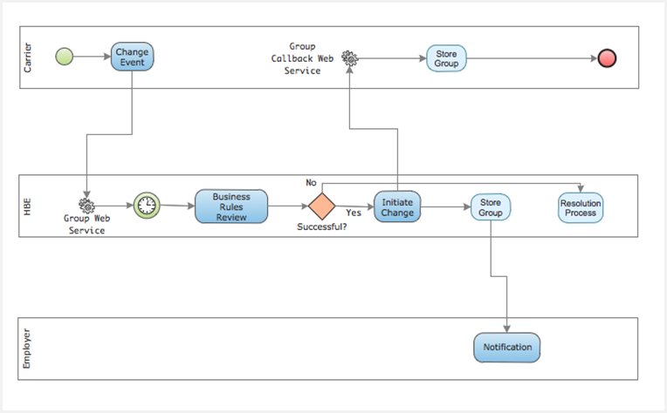

Exhibit 4: Group Maintenance Initiated by Carrier

The sequence in this instance begins with a business condition or event that is known or received initially by the Carrier, and needing to be conveyed to the Exchange. In fact, the only condition identified that will be initiated by Carriers for Group Maintenance will be terminations for non-payment. The steps involved are:

1. The Carrier calls the VT HBE Group Web Service with an action of “Cancel” (as an example).
2. VT HBE asynchronously evaluates the request against its known data and business rules.
3. If the request can be carried out, VT HBE calls the Carrier’s Group Callback Web Service, confirming the cancellation.
4. If the request cannot be carried out, a resolution process is followed as described in the accompanying *Carrier Enrollment Companion Guide*.
5. The state of the Group is stored in both systems.
6. Any notification due Group employer or enrolled Employees is sent.

### Employee Enrollment

Once the Group is created, Employees that have been listed, or will become listed prior to the pre-enrollment deadline on that Group’s employer’s roster can register in the Exchange, qualify, and select from the plans their employer has made available in the Group. The point at which the following business process actually initiates messaging to the Carriers (conveying the enrollment) is dependent on premium payment confirmation, a process that is outside the scope of this document.

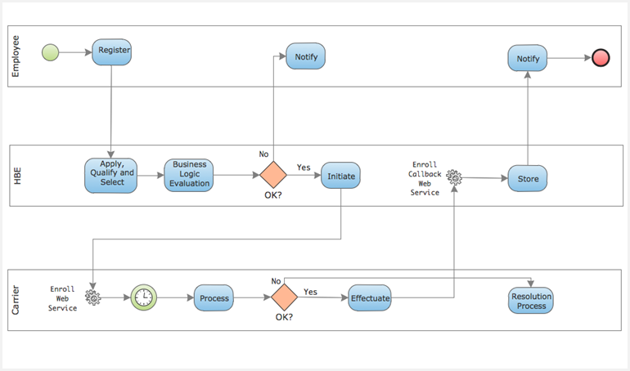

Exhibit 5: Employee Enrollment

The steps in the previous diagram progress as follows:

1. At whatever point the Group has been confirmed by appropriate Carrier(s), employees of that employer may register on the Exchange and browse the plans available to them in the Group.
2. They are qualified, and make their choice during their open enrollment period.
3. At the point that a) the Group has been confirmed and b) VT HBE has received notice of initial premium payment settlement, VT HBE will ‘package’ up all current enrollees in a particular Group and call the Carrier’s Enroll Web Service.
4. The Carrier(s) asynchronously process the enrollments and for all successful enrollees make a call with Effectuated data to the VT HBE’s Enroll Callback Web Service.
5. For those enrollments that could not be processed, if any, a resolution process is followed as described in the *Carrier Enrollment ICD Companion Guide.*

### Employee Maintenance Initiated by VT HBE

There are several business conditions or events that can trigger Employee enrollment changes, such as coverage changes due to life events, APTC election changes, cancellations, etc. Most of those conditions or events will be initiated on the part of the Employee or VT HBE.

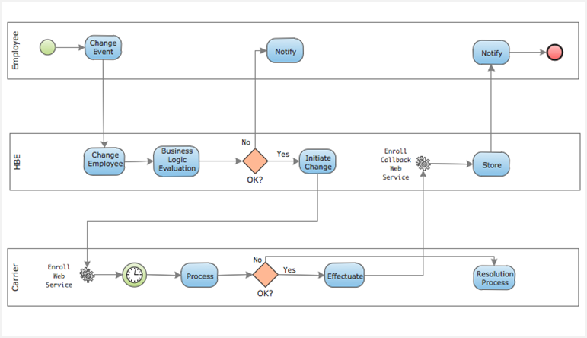

Exhibit 6: Employee Maintenance Initiated by VT HBE

The process is virtually identical to the Employee enrollment process:

1. Either the Employee, or the VT HBE system due to some triggering condition, creates need for an enrollment change to be processed by the Exchange.
2. The system evaluates the nature of the change request in terms of business logic and rules.
3. If it is an invalid request, notification of the issue is sent to the appropriate party.
4. If valid, the Carrier Enroll Web Service is called, with an action of “Change” and corresponding data are provided to indicate the nature of the change.
5. The Carrier asynchronously evaluates the enrollment change request.
6. If it can be carried out, it is processed and a confirmation message sent to the VT HBE Enroll Callback Web Service.
7. If it cannot be carried out, the resolution process will be followed as described in the *Carrier Enrollment ICD Companion Guide*.
8. In any case, appropriate notification of enrollment status is sent.

### Employee Maintenance Initiated by Carrier

This process supports any business condition that initiates a change to an Employee enrollment state from the Carrier. The only identified scenario that would cause the Carriers to initiate a Change notification would be termination for non-payment.

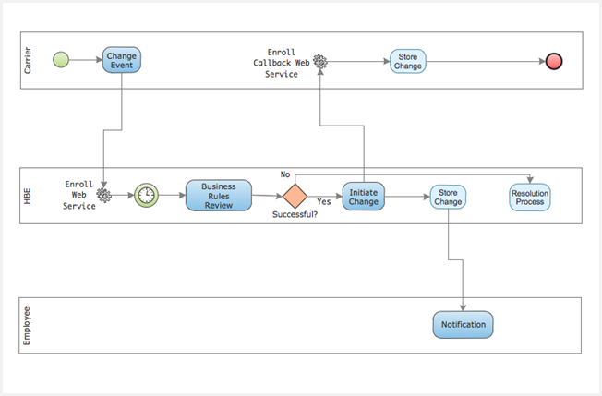

Exhibit 7: Employee Maintenance Initiated by Carrier

The process for conveying Employee enrollment changes is virtually identical to the Employee initial enrollment process:

1. A business condition (such as non-payment beyond the grace period) causes the Carrier to create a cancellation message, and call the VT HBE Enroll Web Service with an action type of “Change” and other appropriate data.
2. VT HBE asynchronously evaluates the change request, applies known business logic and appropriate business rules to the request and evaluates validity.
3. If the request is valid, VT HBE builds an appropriate confirmation message and calls the Carrier’s Enroll Callback Web Service.
4. If the request is not valid, a resolution process is followed as described in the *Carrier Enrollment ICD Companion Guide*.
5. Both systems then store the state of the change, and appropriate notifications are delivered.

### Individual Enrollment

There is very little difference, in terms of the overall business process, between enrolling an unaffiliated individual and enrolling an employee into an employer-defined Group. There are some differences in specific data required, but the process itself is virtually identical.

In both cases, the message content exchanged via the web services on both VT HBE’s and the Carrier’s part are standard EDI documents, though as mentioned previously, the transactional nature of the exchanges is non-standard (as defined by CMS).

Transmission of enrollments to the Carrier are always dependent on validation of initial premium payment (defined by notification of settlement to HBE); processes that are defined in a separate ICD.

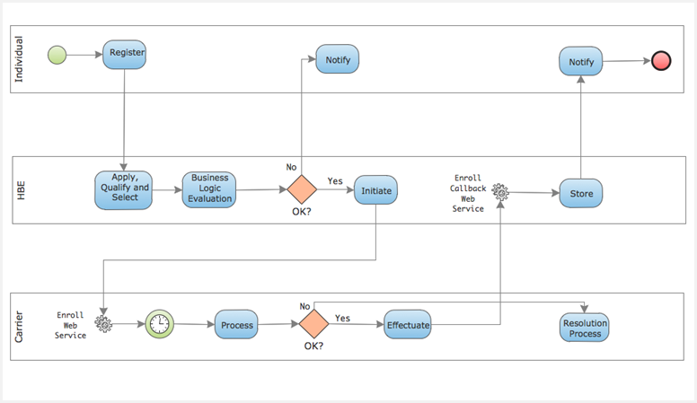

Exhibit 8: Individual Enrollment

The process of individual enrollment begins in the VT HBE Portal, where an eventual applicant register themselves, applies for qualification, reviews and ultimately selects a QHP.

The business process at that point follows:

1. The individual’s selection is reviewed by the VT HBE system in terms of business logic and rules.
2. Once validated, VT HBE formulates an enrollment message and calls the appropriate Carrier’s Enroll Web Service.
3. The Carrier asynchronously processes the enrollment request.
4. If the enrollment request is successful, the Carrier calls the VT HBE Enroll Callback Web Service, passing Effectuated data to it as confirmation of the enrollment.
5. If the Carrier cannot complete the enrollment successfully, a resolution process is followed as described in the *Carrier Enrollment ICD Companion Guide*.
6. VT HBE and Carrier stores the enrollment state and appropriate notification is given to the Individual.

### Individual Enrollment Maintenance Initiated by VT HBE

As with Employees, there are conditions and events – triggered either by the individual or the VT HBE system – that mandate a change in enrollment status. These may be items such as life-change events (additions to the household) or self-cancellation of coverage.

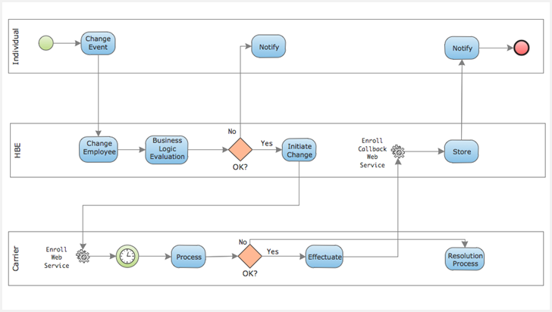

Exhibit 9: Individual Enrollment Maintenance Initiated by VT HBE

The steps in the process are:

1. Whatever the event or condition, the VT HBE system evaluates appropriate business rules and logic and determines the validity of the change request.
2. If the request is not determined as valid, notification is sent to the Individual through the message page in the system.
3. If the request is valid, VT HBE formulates an appropriate message and calls the Carrier Enroll Web Service, indicating a ‘Change’ request.
4. Asynchronously, the Carrier processes the request and if it is able to execute the change, it packages appropriate effectuation data and calls the VT HBE Enroll Callback Web Service.
5. If the change cannot be carried out as sent, a resolution process is followed as described in the *Carrier Enrollment ICD Companion Guide*.
6. Regardless of outcome, the Individual initiating (or the subject of) the request receives appropriate notice.
7. Both parties store the state of the enrollment change.

### Individual Enrollment Maintenance Initiated by Carrier

Individual enrollment changes can also be driven by conditions or events occurring at the Carrier. The only identified event requiring the Carrier to initiate an enrollment change message is cancellations for non-payment. The actual process of making the change is virtually identical to that for Employees.

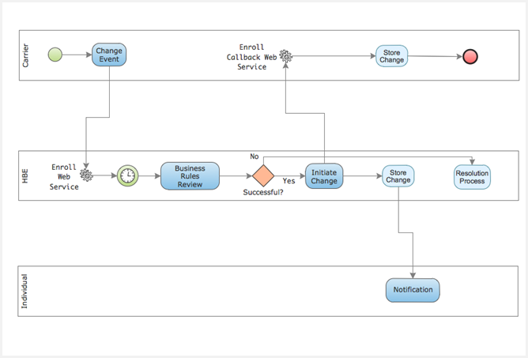

Exhibit 10: Individual Enrollment Maintenance Initiated by Carrier

The steps illustrated in the previous diagram are as follows:

1. Whatever the business condition or event that the Carrier has identified, it has been validated as valid and appropriate (in the case of the Carrier, that would only be for termination due to non-payment).
2. The Carrier packages the message appropriately and calls the VT HBE Enroll Web Service, indicating a ‘Change’ action.
3. Asynchronously, VT HBE evaluates the change request, applying business rules and logic.
4. If VT HBE determines the request is valid, it sends confirming data to the Carrier’s Enroll Callback Web Service.
5. If VT HBE determines the request is invalid for some reason, a resolution process will be followed as described in the *Carrier ICD Enrollment Companion Guide*.
6. Irrespective of the outcome, the state of the change is stored in both Carrier and VT HBE systems, and appropriate notice is sent to the individual.

## Service Operations

The services shown in the following two tables are meant to depict logical web service endpoints. In other words, there are several ways to physically provide the various individual service calls that are described here.

Notice that both tables are literally identical in terms of general service functionality. Only the event types that trigger the use of the services will differ.

However the actual physical endpoints are designed and implemented, what’s important to take away from these tables is that there are only four logical endpoints that need to be provided for; for both VT HBE and Carriers, each will provide “Group” and “Enrollment” Web Services that the partner is able to call to initiate a transaction, and each will provide “Group Callback” and “Enrollment Callback” web services that the partner is able to call to complete transactions.

Exhibit 11: Web Services Hosted by VT HBE

| Service Host | Service | Triggering Events |
| --- | --- | --- |
| VT HBE | Group Web Service – Provides services for all Group-related operations | * Carrier encounters need to terminate Group for non-payment |
| VT HBE | Enrollment Web Service – Provides services for all enrollment-related operations | * Carrier encounters need to terminate individual enrollee for non-payment * Carrier encounters need to terminate employee enrollee for non-payment of Group |
| VT HBE | Group Callback Web Service – Provides services for Carriers to call to complete operational transactions; e.g., Group creation confirmations | * Carrier has received Web Service call from VT HBE to its own Group Web Service |
| VT HBE | Enrollment Callback Web Service – Provides services for Carriers to call to complete operational transactions; e.g., sending Effectuated enrollment data | * Carrier has received Web Service call from VT HBE to its own Enrollment Web Service |

Exhibit 12: Web Services Hosted by Carrier

| Service Host | Service | Triggering Events |
| --- | --- | --- |
| Carrier | Group Web Service – Provides services for all Group-related operations | * Employer confirms Group creation * Employer, or other source, signifies a change to a Group |
| Carrier | Enrollment Web Service – Provides services for all enrollment-related operations | * Individual enrolls in a QHP and makes payment Carrier encounters need to terminate employee enrollee for non-payment of Group * Employee enrolls in a Group and employer makes payment * Employee, Employer, Individual or other source signifies a change to a current enrollment |
| Carrier | Group Callback Web Service – Provides services for Carriers to call to complete operational transactions; e.g., Group creation confirmations | * VT HBE has received Web Service call from Carrier to its own Group Web Service |
| Carrier | Enrollment Callback Web Service – Provides services for Carriers to call to complete operational transactions; e.g., sending Effectuated enrollment data | * VT HBE has received Web Service call from Carrier to its own Enrollment Web Service |

## Data Handling

### Group Operations

Both VT HBE and Carriers will use the standard Group Operation message structures described later in this document. Data will be packaged into a standard SOAP envelope as XML, and securely sent to the receiving web service endpoint.

Also described is both the synchronous acknowledgement that is expected to the initial call, and the subsequent asynchronous callback message to complete the transaction.

### Enrollment Operations

Enrollment operations present a more complex picture, though more standardized. For all enrollment operations, both VT HBE and Carriers will use the CMS FFE version of the EDI X12 834 document structure, contained in a standard SOAP envelope as XML.

The synchronous response expected is essentially a TA1 structure, acknowledging that the 834 was successfully read.

The subsequent asynchronous callback completing the transaction will be distinct message structures (contained within the same message body).

* For Carriers, a standard EDI validation error message will be conveyed in the event the 834 is ill-formed, or otherwise unable to be handled by their internal system processing (*Note: the exact nature of that message is TBD, pending carrier review*.)
* For Carriers, an Effectuated 834 will be constructed for all new enrollments. For Carriers, an ‘end of processing’ 834 will be sent, similar to an effectuated 834, containing changes the carrier has made to the data fields that were sent. For VT HBE, an “echo” will be sent, verifying receipt of what was sent by the Carrier.
* For both Carriers and VT HBE – and provided only in the case of “Change” type 834’s - a ‘Confirmation’ 834 will be sent, confirming the changes that were made by the receiving party.

## Process Controls

The general goal of process controls is to help ensure that whether the transactional protocol is file-based or web service based, procedures are in place to deterministically monitor message delivery and response.

For web service based messaging, the operational controls include:

* The provision of formal WSDL definitions and associated XSD’s for all services
* Expectation of synchronous acknowledgement of all request messages (via TA1 responses)
* Detailed logging of all messaging and data movement
* Standardized transmission security controls (see the *Security* section in the *Carrier Enrollment ICD Companion Guide*)
* A rigid set of SLA’s that establish acceptable response windows within which to respond to an “initiating” web service call with an acceptable callback.
* ‘Ping’ mechanisms to monitor service availability
* SOA Suite BAM event triggers to monitor and report on message activity and behavior

For traditional EDI (file-based) transfers (applicable only to reconciliation files, reports and other static materials) operational controls include:

* A notification “alert” mechanism to prompt the receiving SFTP resource to expect a file transfer within an agreed upon timeframe
* A companion “trigger” file whose appearance in the directory implies that the actual target file has successfully completed transmission
* A comprehensive file naming protocol that clearly identifies sender, date and time, file type, and purpose
* A file transfer calendar that sets rigid duration thresholds for expectation of file delivery (as in the example above, for instance – that a reconciliation file exchange would occur monthly)
* Encryption key refreshes on a regular basis (monthly)

## Security and Integrity

Security for any Health Exchange and its partners is absolutely paramount. Federal guidelines mandate adherence to high standards, and these standards provide an overarching umbrella over all data exchanges and the various infrastructures, mechanisms, and operations providing those data.

In general, processes and technology must be provided to effectively secure the following aspects of data exchange covered by the ICD:

* Secure encryption/decryption mechanisms and techniques for all data movements
* Secure, standardized definition and implementation of web services security, including the transport layer
* Comprehensive authentication mechanisms for web service calls and SFTP transfers, including signed certificates from an authorizing body
* Comprehensive logging of all activity related to data movement

Please refer to the *Carrier Enrollment ICD Companion Guide* to this document for a more comprehensive review of web service standards that will apply, as well as an SFTP framework designed to support security and reliability of file transfers.

# Detailed Interface Design

The scope of the Carrier-ENR ICD encompasses three discrete layers architecturally:

* The VT HBE system is comprised of a customized Liferay portal, and numerous Oracle products, primary among them Siebel, SOA Suite, IDM, and WebCenter Content. This system should in general be viewed conceptually as the “internal” system, with the Liferay portal providing the public-facing, UI for users accessing the system from a browser, and customer service and call center resources accessing data, administrative screens, and processes through the Siebel CRM applications.
* A logical “mediation layer” composed of SOA Suite composites (mediators, BPEL processes, and adapters) whose purpose is to provide access for the Portal and Siebel applications to external services. This layer is referred to as the VT HBE Integration Hub (HIH).
* The Carrier infrastructures providing specific SOAP-based Web Services and SFTP file transfer directories.

In general, the topology of these systems forms a single access point, or gateway, between the broad application functionality of the ‘front end’ and the services provided by external resources, such as carriers and CMS. The purpose of this is to provide control and tracking of traffic between service providers and clients, and to help ensure that the business process implications of many of these external services are fully visible and managed.

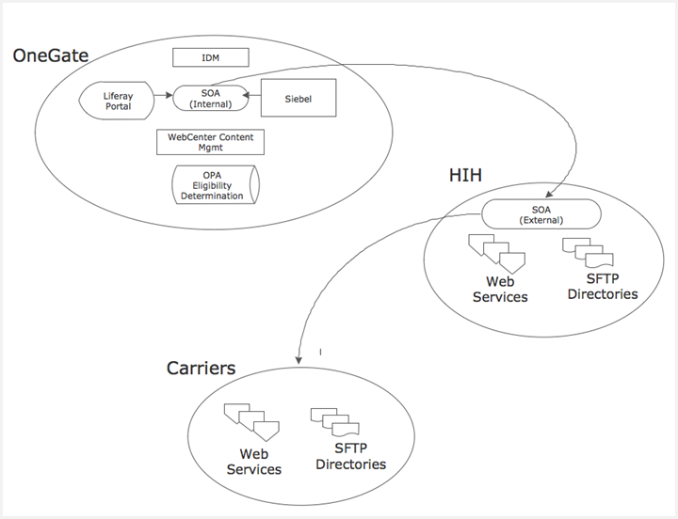

Exhibit 13: Basic System Components

The previous diagram provides a high-level overview of the components comprising the VT HBE infrastructure. The critical concept to extract from this diagram is that the VT HBE system itself is logically isolated from external interfaces, with all traffic being routed through the VT HBE Integration Hub, which provides a set of Web Services (for transactional operations such as Group and Enrollment services) and SFTP directories (for conveyance of static materials such as reconciliation files and reports) and functions to provide a mediation layer for data exchange between the VT HBE System and external Vermont Partners such as Carriers.

From the Carrier perspective, they are providing similar infrastructures, software and support services as the HIH, in order to provide for the transparency, reliability, and transactional capabilities of web service based messaging.

## Event-Driven Sequences

The sequence diagrams that follow provide detailed messaging information for four basic sequences:

* New Group
* New Enrollment
* Change Group
* Change Enrollment

Although there are several variations of the “change” flows from a business initiation standpoint, the sequences are identical. For example, whether an enrollment change is initiated by the Carrier to the VT HBE (in the case of a termination) or initiated by the VT HBE to the Carrier, the “responder” will always provide an Enrollment Web Service, and the “initiator” will always provide a corresponding Enrollment Callback Web Service. The details of the message exchange and error handling processes are exactly the same in either case.

It is also important to note that these various web services are depicted as logical entities, not necessarily as either the VT HBE or the Carrier may choose to physically implement. For example, the Carrier may choose to implement a separate web service for error handling, instead of collapsing various call signatures and functionality into a single endpoint. These are minor implementation details and do not affect the fundamental flow depicted in the diagrams.

One of the logical depictions is the “Error Queue” which is intended as a repository for all business logic exceptions. This will need to exist both within the Carrier’s system as well as VT HBE. It’s intended to allow the accumulation of “pending” transactions of any kind that have failed for whatever reason. The process for resolving those errors is then manual, and is described in the *Carrier Enrollment ICD Companion Guide*.

Also, note that the distinction between the VT HBE “system” and the VT HBE “Integration Hub” has been removed in this version of the document. From the Carrier standpoint, though this is a real architectural distinction for VT HBE, it has no bearing on the nature of the message exchanges. It has been eliminated to provide clarity.

### New Group

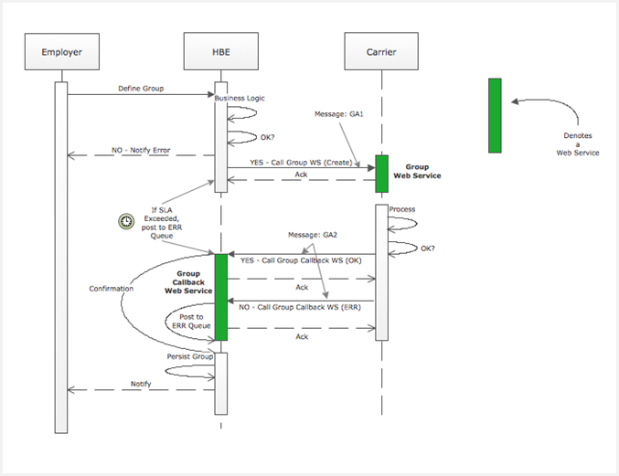

Exhibit 14: New Group Sequence

The New Group Sequence diagram above depicts a fairly straight-forward call flow; one that is always initiated by VT HBE:

1. Once open enrollment is closed, the VT HBE system validates the data (as well as circumstances related to business rules and logic) associated with the creation of an employer group.
2. The VT HBE system calls the Group Web Service that the Carrier hosts, using a GA1 message structure (described later in this document). VT HBE, as for all Web Service calls, will expect a synchronous acknowledgement.
3. The Carrier then processes the GA1 message, and determines whether it can create the Group that’s been described in the message. If it can, it calls the VT HBE Group Callback Web Service, using a GA2 message structure (also described later in this document).
4. If errors exist, the Carrier will still make a call to the VT HBE Group Callback Web Service, using a GA2 message structure, but in this case, the message will contain error data.
5. Note that the diagram depicts two distinct business exception conditions (as opposed to technical delivery exceptions) that are handled by entering error messages on a Queue:
   1. An SLA exception (essentially, a ‘time-out’ wherein the expected call to the Group Callback Web Service was not made within the acceptable timeframe [TBD])
   2. The call to the Group Callback Web Service contains an error
6. Regardless of outcome, notification is sent to the employer initiating the request.

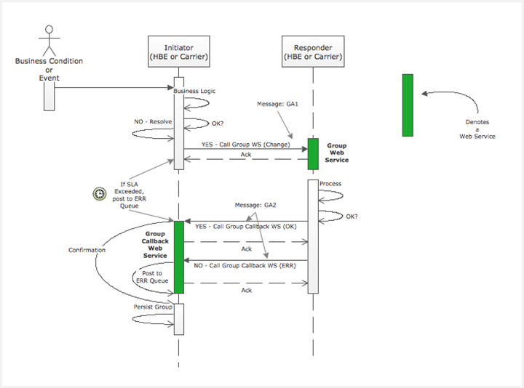

Exhibit 15: Group Change Sequence

The general process for Group Change is similar to New Group, with the exception that either VT HBE or Carriers can be the initiator, as well as the responder. In either case, the sequence is as follows:

1. Some business condition or event triggers the need for a change to a group to take place. In the case of the Carrier, this would only be termination of the group due to non-payment.
2. The initiating party prepares a GA1 message, this time with an action type of “Change”, and calls the responder’s Group Web Service. The responder is obligated to synchronously acknowledge reception of the message.
3. The responder applies business rules and corresponding business logic, and assuming that the request can be acted upon, calls the Group Callback Web Service of the initiator, using a GA2 message containing a reflection of the data sent by the initiator.
4. Again, there are two business logic exceptions that are identified in the diagram that would utilize the resolution process described in the *Carrier Enrollment ICD Companion Guide*:
   1. SLA exception – where the Group Callback Web Service did not receive the callback within the allotted time
   2. An error was expressly sent by the responder to the Group Callback Web Service, using the GA2 message, this time indicating a logical business exception
5. The state of the group change is persisted by both initiator and responder.

### New Enrollment

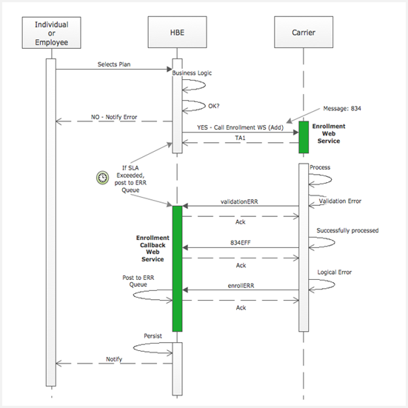

Exhibit 16: New Enrollment Sequence

The New Enrollment Sequence is more involved, in that there are multiple messages required from the Carrier when successful processing of the 834 can occur. The sequence, as depicted above, is:

1. An individual or employee selects a plan, which triggers the evaluation of the selection using business rules and logic that VT HBE applies (including payment, outside the scope of this document).
2. Assuming the selection and circumstances surrounding the selection allow VT HBE to proceed with enrollment, a CMS FFE-consistent version (see the *Carrier Enrollment ICD Companion Guide*) of the EDI X12N 834 message is constructed and used to call the Carrier’s Enroll Web Service. VT HBE expects a synchronous acknowledgement back, explicitly in the form of a TA1 message.
3. If the Carrier’s EDI validation process indicates an exception, a validationERR message (the exact format of this is still pending with the carriers) is sent to the VT HBE Enroll Callback Web Service for the applicable 834 transaction.
4. For those transactions that are validated, two further processing related types of business logic exceptions can occur:

* The length of time to receive a corresponding call to the VT HBE Enroll Callback Web Service by the Carrier exceeds SLA limits
* The Carrier communicates a business logic error via the enrollERR message structure to the VT HBE Enroll Callback Web Service

1. Assuming neither of these business logic exceptions occur, the Carrier asynchronously then sends the following message to the VT HBE Enrollment Callback Web Service:

* 834EFF – providing Effectuation data

1. As always, VT HBE will respond with synchronous acknowledgements to all web service calls.
2. Both VT HBE and Carrier persist the new enrollment state, and the individual or employee requesting the enrollment is appropriately notified.

### Enrollment Change

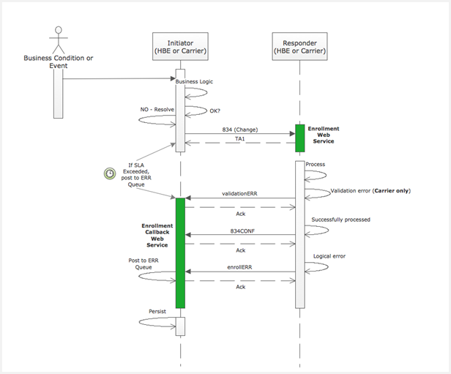

Exhibit 17: Enrollment Change Sequence

The Enrollment Change Sequence is initiated for any standard enrollment change process, and is very similar to the new enrollment process, except that either VT HBE or the Carrier can be the initiating party, and either VT HBE or the Carrier can be the responding party.

In either case, the sequence of events is the same:

1. A business condition or event, either at VT HBE or the Carrier, initiates a change request, which is evaluated for validity through the application of business rules and logic. As stated above, the only change condition that causes the Carrier to be the initiator is a termination request for non-payment.
2. Assuming a valid request, the initiator packages the request appropriately into an 834 message, and sends it to the responder’s Enroll Web Service, which provides a synchronous response in the form of a TA1.
3. If validation errors occur for any 834 transaction message, a validation ERR is sent to the initiator’s Enroll Callback Web Service for that transaction.
4. At this point, two business logic exceptions can now arise:

* The allotted time between the call going to the responder’s Enroll Web Service and the corresponding callback coming to the initiator’s Enroll Callback Web Service is exceeded.
* The responder encounters a logical error and indicates that with the transmission to the Enroll Callback Web Service of an enrollERR message, containing one of a fixed set of logical business error conditions, as defined by the carriers.

1. Assuming neither occurs, the responder is now obligated to send the following message to the initiator’s Enrollment Callback Web Service:

* An 834CONF message

1. The enrollment change state is persisted by both parties, and any specific internal processing that needs to occur is carried out.

## Message Data

The only message definitions and layouts that are directly covered in this document are those used for Group operations. All 834 enrollment messages are based on EDI standard documents, and as such, are addressed in their entirety within the 834 *Companion Guide* accompanying this ICD. The VT HBE-defined response messages to 834 transactions (834EFF, 834CONF, validationERR and enrollERR) are also defined in the *Carrier Enrollment ICD Companion Guide*.

### GA1 (Request Message)

The following table identify GA1 Request Message header and body data.

**Header**

Exhibit 18: GA1 Header Data

|  |  |  |  |  |  |
| --- | --- | --- | --- | --- | --- |
| Data Item | Type | Mandatory | Description | Min | Max |
| messageID | AlphaNumeric | Yes | Generated by VT HBE; unique to the message | 2 | 50 |
| carrierID | Alphanumeric | Yes | ID assigned by VT HBE to represent the carrier (from Carrier meta-data) | 2 | 50 |
| DateTime | Numeric | Yes | CCYYMMDDHHMMSS | 14 | 14 |
| ActionType | Numeric | Yes | 1 – Indicates ‘new’ Group operation  2 – Indicates ‘remove’ Group operation  3 – Indicates ‘change’ Group operation | 1 | 1 |

**Body**

Exhibit 19: GA1 Body Data

| Data Item | Type | Mandatory | Description | Min | Max |
| --- | --- | --- | --- | --- | --- |
| groupID | Numeric | Yes | Unique ID created by VT HBE for this Group | 2 | 50 |
| currentAgentFirstName | Alpha | No | This is an element of the group ID. This can be a repeating element  First name of agent | 2 | 50 |
| currentAgentLastName | Alpha | No | This is an element of the group ID. This can be a repeating element  Last name of agent | 2 | 50 |
| currentAgentID | AlphaNumeric | No | License number of agent. | 2 | 35 |
| currentAgentEffectiveDate | Date | No | Effective date the policy began related to the agent commission schedule.  CCYYMMDD | 8 | 8 |
| currentAgentEndDate | Date | No | Effective end date of the policy related to the agent commission schedule.  CCYYMMDD | 8 | 8 |
| previousAgentFirstName | Alpha | No | This is an element of the group ID. This can be a repeating element  First name of agent | 2 | 50 |
| preiousAgentLastName | Alpha | No | Last name of agent | 2 | 50 |
| previousAgentID | AlphaNumeric | No | License number of agent. Numbers will always be preceded by an alpha character assigned by INIS | 2 | 35 |
| previousAgentEffectiveDate | Date | No | Effective date the policy began related to the agent commission schedule.  CCYYMMDD | 8 | 8 |
| previousAgentEndDate | Date | No | Effective end date of the policy related to the agent commission schedule.  CCYYMMDD | 8 | 8 |
| companyName | AlphaNumeric | Yes | Official corporate / legal name | 2 | 100 |
| companyDBA | AlphaNumeric | No | Doing business as | 2 | 100 |
| taxID | AlphaNumeric |  | Federal EIN | 2 | 50 |
| *Note there are 3 address types for company, contract and mailing.* | | | | | |
| companyAddress1 | AlphaNumeric | Yes | Corporate Address | 2 | 200 |
| companyAddress2 | AlphaNumeric | No | Corporate Address | 2 | 100 |
| companyAddress3 | AlphaNumeric | No | Corporate Address | 2 | 100 |
| companyAddress4 | AlphaNumeric | No | Corporate Address | 2 | 100 |
| companyCity | Alpha | Yes | Name of city | 2 | 50 |
| companyState | Alpha | Yes | Standard postal code for State | 2 | 2 |
| companyPostalCode | Numeric | Yes | 5 digit zip code; preferably with the + 4. | 5 | 9 |
| companyPhone | Numeric | Yes | Phone number | 10 | 10 |
| companyFax | Numeric | No | Fax number | 10 | 10 |
| companyAdminFirstName | Alpha | Yes | First name of corporate administrator | 2 | 50 |
| companyAdminLastName | Alpha | Yes | Last name of corporate administrator | 2 | 50 |
| companyEmailAddress | Alphanumeric | No | Email address of corporate contact | 4 | 350 |
| contactAddress1 | AlphaNumeric | Yes | Contract Address | 2 | 200 |
| contactAddress2 | AlphaNumeric | No | Contract Address | 2 | 100 |
| contactAddress3 | AlphaNumeric | No | Contract Address | 2 | 100 |
| contactAddress4 | AlphaNumeric | No | Contract Address | 2 | 100 |
| contactCity | Alpha | Yes | Name of city | 2 | 50 |
| contactState | Alpha | Yes | Standard postal code for State | 2 | 2 |
| contactPostalCode | Numeric | Yes | 5 digit zip code; preferably with the + 4. | 5 | 9 |
| contractPhone | Numeric | Yes | Phone number | 10 | 10 |
| contactFax | Numeric | No | Fax number | 10 | 10 |
| contactAdminFirstName | Alpha | Yes | First name of Contract administrator | 2 | 50 |
| contactAdminLastName | Alpha | Yes | Last name of Contract administrator | 2 | 50 |
| contactEmailAddress | Alphanumeric | No | Email address of Contract contact | 4 | 350 |
| mailingAddress1 | AlphaNumeric | Yes | mailing Address | 2 | 200 |
| mailingAddress2 | AlphaNumeric | No | mailing Address | 2 | 100 |
| mailingAddress3 | AlphaNumeric | No | mailing Address | 2 | 100 |
| mailingAddress4 | AlphaNumeric | No | mailing Address | 2 | 100 |
| contactAddress3 | AlphaNumeric | No | Contract Address | 2 | 100 |
| mailingCity | Alpha | Yes | Name of city | 2 | 50 |
| mailingState | Alpha | Yes | Standard postal code for State | 2 | 2 |
| mailingPostalCode | Numeric | Yes | 5 digit zip code; preferably with the + 4. | 5 | 9 |
| mailingPhone | Numeric | Yes | Phone number | 10 | 10 |
| mailingFax | Numeric | No | Fax number | 10 | 10 |
| mailingAdminFirstName | Alpha | Yes | First name of mailing administrator | 2 | 50 |
| mailingAdminLastName | Alpha | Yes | Last name of mailing administrator | 2 | 50 |
| mailingEmailAddress | Alphanumeric | No | Email address of mailing contact | 4 | 350 |
| companySize | Numeric | Yes | Number of Vermont employees | 1 | 6 |
| employerContributionEE | Currency | Yes | Employer contribution for employee |  | 2  decimals |
| employerContributionDP | Currency |  | Employer contribution for dependents |  | 2  decimals |
| employeeContribution | Currency | Yes | Percentage |  | 2  decimals |
| originalEffectiveDate | Date | Yes | MMDDYYYY | 8 | 8 |
| changeEffectiveDate | Date | Yes | MMDDYYYY | 8 | 8 |
| minimumWorkHours | Numeric | Yes |  | 1 | 2 |
| cobraOrState | Alpha | No | C = Cobra; S = State | 1 | 1 |
| probationaryPeriods | Numeric | No | 1, 20, 60, or 90 | 1 | 2 |
| electionPeriod | Alpha | No | Number of days | 1 | 3 |
| bargainingUnion | Alpha | No | Effective begin/end date MMDDYYYY/MMDDYYYY | 17 | 17 |
| coverageType | Alpha | Yes | EMP = Employee Only or ALL = Family | 3 | 3 |
| benefitCode | Alpha | No | T = Tax Equity and Fiscal Responsibility Act | 1 | 1 |
| outOfState | Alpha | Yes | Y = Yes; N = No | 1 | 1 |

### GA2 (Response Message)

Note that the GA2 message is not a “response” in the sense of a synchronous web service; it is a response in the sense of a logical business operation. Physically, it is an asynchronous call to the initiator, who is providing their own “callback” web service for this purpose.

The GA1 call, as are all web service call sequences described in this document, synchronously responded to only with an acknowledgement of successful reception of the message. The following table identify GA2 header and body data.

**Header**

Exhibit 20: GA2 Header Data

|  |  |  |  |  |  |
| --- | --- | --- | --- | --- | --- |
| Data Item | Type | Mandatory | Description | Min | Max |
| messageID | AlphaNumeric | Yes | As sent in Request | 2 | 50 |
| carrierID | Alphanumeric | Yes | Standard | 2 | 50 |
| dateTime | Numeric | Yes | CCYYMMDDHHMMSS | 14 | 14 |

**Body**

Exhibit 21: GA2 Body Data

|  |  |  |  |  |  |
| --- | --- | --- | --- | --- | --- |
| Data Item | Type | Mandatory | Description | Min | Max |
| messageID | AlphaNumeric | Yes | As sent in Request | 2 | 50 |
| carrierID | Alphanumeric | Yes | Standard | 2 | 50 |
| dateTime | Numeric | Yes | CCYYMMDDHHMMSS | 14 | 14 |

## Packaging and Delivery

There are two basic operations, each requiring a different approach toward packaging and operational delivery methods; web service based calls, and file exchange processes. Details for each of these two operations are identified below.

**Web Services**

* Standard WS-ReliableMessaging and WS-Security (1.1) standards will be followed
* VT HBE will implement a comprehensive system of BAM event triggers, providing for real-time tracking of traffic activity through the various layers of the SOA composites carrying out the web service provision and consumption.
* Comprehensive Logging will also be provided, with both header and body data, as well as network addresses, time of day and operation attempted being recorded for all activity.
* See the *Transactions* section below for further identification of Web Service packaging and delivery expectations and management. Also, note that the *Carrier Enrollment ICD Companion Guide* provides a more detailed description of Web Service Security practices to be implemented.

**SFTP**

* Enrollment operations will be preceded with a notification to the Carrier, in an agreed-upon fashion. This could be email, a web service call, a notification file, or some other procedure.
* All file upload operations will be followed by a small “trigger” file that signifies the file provider completed the primary file upload operation successfully. The presence of a primary file, even an expected one, without the trigger file means the primary file is suspect and a ‘missing file’ resolution process needs to be triggered. The trigger file should meet the naming convention specified below.
* Once a file is successfully received by the target, the receiver is expected to upload a small acknowledgement file to the SFTP directory of the original file’s source, identifying the name of the file received, the date and time it was placed. The acknowledgement file should meet the naming convention specified below.
* Carriers and VT HBE will work out a file naming convention for all files to be exchanged. The naming convention needs to achieve the following goals:
* Each name is guaranteed to be reliably unique
* The name alone will identify the source of the file, the type of operation that it is meant to participate in, the party that is the target of the file, and the day and time it was sent
* All files should be encrypted (the suggested technique is PGP) and sent via SFTP. Carriers and VT HBE will maintain individual key stores in appropriately secure fashion, and keys will be regularly changed.

### Technical Plan – SFTP Exchange

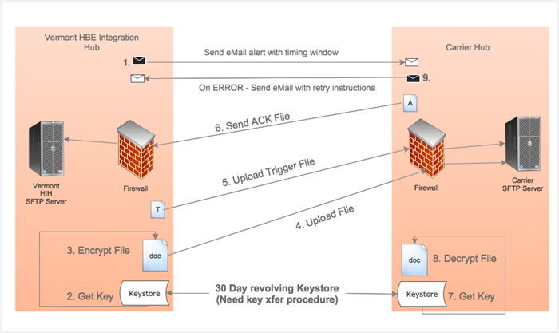

Exhibit 22: SFTP Exchange Technical Plan

The steps involved in carrying out a single SFTP exchange are described in the proposed technical plan above. The goals of this somewhat cumbersome approach are to help ensure that when a file shows up, it is expected, and if one is expected, its absence is notable.

Further, the explicit pre-transmission encryption helps ensure that even Server operators are not able to view these documents.

The following are additional points of clarification:

1. The ‘alert’ mechanism, which indicates to the carrier that a file will soon be sent, is an email to an agreed-upon addressee indicating the start of a timing ‘window’ within which the file transfer will take place.
2. The ‘trigger file’ is never read; its significance is in its presence. That is, when the primary file completes a successful upload, the small, empty trigger file is sent to indicate to the carrier that the primary file is ready to be read.

### System Architecture

The system infrastructure upon which the VT HBE services are provided, and the VT HBE system itself is installed and configured, is described in its entirety in other documents not directly related to this ICD and associated *Carrier Enrollment ICD Companion Guide*.

## Transactional Requirements

There are no formal transaction requirements represented in this ICD. However, there are several transactional-style conventions that have been noted:

* Web service calls will always be responded to in an acknowledgement of transmission sense, so that the consumer of the web service can confirm a successful call.
* There are numerous “operational pairs” described in this ICD, where two call sequences (one request/response call in one direction and a second request/response call in the other) exist. The expectation is that the integrity and reliability of these pseudo transactions will be explicitly enforced through call/response tracking.

The expected ‘transaction groups’ are as follows:

1. For Group Create
   1. VT HBE calls Carrier Group Web Service
   2. Carrier calls back VT HBE Group Callback Web Service
2. For Group Changes
   1. VT HBE calls Carrier Group Web Service
   2. Carrier calls back VT HBE Carrier Callback Web Service

OR:

* 1. Carrier calls VT HBE Group Web Service
  2. VT HBE calls back Carrier Group Callback Web Service

1. For New Enrollment Operations
   1. VT HBE calls Carrier Enroll Web Service
   2. Carrier calls back VT HBE Enroll Callback Web Service
2. For Enrollment Changes
   1. VT HBE calls Carrier Enroll Web Service
   2. Carrier calls back VT HBE Enroll Callback Web Service

OR:

* 1. Carrier calls VT HBE Enroll Web Service
  2. VT HBE calls back Carrier Enroll Callback Web Service

## Security Management

Please see the *Carrier Enrollment ICD Companion Guide* accompanying this document for a full specification of security guidelines related to web service implementation. Further, note that detailed security implementation instructions will be provided to carrier’s during technical/testing sessions subsequent to the final delivery of this document.

## Business Rules

There are no explicit business rules identified yet for this ICD. This is one of the items needing discussion between Carriers and the State of Vermont.

## Exception Handling

There are two fundamental families of exceptions that can occur within the scope of message and file exchanges between VT HBE and Carriers:

* Technical exceptions, consisting of network and software errors. These are expected to be handled in a standard fashion; for example, through an agreed upon process of attempted re-tries or a ‘wait’ period before re-tries occur to give system issues opportunity to be resolved. In any case, at some point, even for technical exceptions, it becomes a manual process of tracking problems down, evaluating logs, etc. These are operational details that need to be added as we VT HBE and Carriers move from the conceptual design stage that a document such as this ICD represents, and into physical testing.
* Business logical exceptions, consisting of circumstances within a transaction that prevent successful completion. For example, if a New Group operation is sent to a Carrier and that Group already exists, a process of resolution needs to be followed to discover and eliminate the source of the faulty transaction, and to help ensure that both partners have the same understanding of the state of that Group.

The *Carrier Enrollment ICD Companion Guide* does provide a reasonable starting point for that process. A more comprehensive business process for problem resolution needs development, but is outside the scope of an ICD or *Carrier Enrollment ICD Companion Guide*.

## Service Performance

There are several aspects of the services described in this ICD that need to have explicit SLA’s established. Again, this is a matter for further discussion as the processes in this document are reviewed.

# VT HBE Process Implications

There are no implications for this ICD in terms of formal business processes.

# General Qualification Plan

The *Carrier Enrollment ICD Companion Guide* accompanying this ICD provides a somewhat high-level review of the discrete steps that are to be followed to qualify and validate the processes and messages described herein.

This document represents a design phase in the evolution of effective interfacing between Carrier and VT HBE. As we evolve from this into actual development and testing, detailed qualification requirements will continue to be communicated.

Appendix A: Acronyms

The following table is a list of acronyms introduced in this document.

Exhibit 23: List of Acronyms

|  |  |
| --- | --- |
| Acronym | Description |
| CMS | Centers for Medicare & Medicaid Services |
| ICD | Interface Control Document |
| LDM | Logical Data Model |
| SDD | System Design Document |
| HIH | VT HBE Integration Hub |
| OPA | Oracle Policy Automation |
| PGP | Pretty Good Privacy |
| SFTP | Secure File Transfer Protocol |